Assignment-1: Collection and SOQL Assignment

- Add the values to the list

public class RecordInsert {
public static void CreateRecord(){
List<Account> a = new List<Account>();
a.add(new Account(Name = 'Micro'));
a.add(new Account(Name = 'Tech'));
insert a;
system.debug('Record Inserted:' + a);
}
}
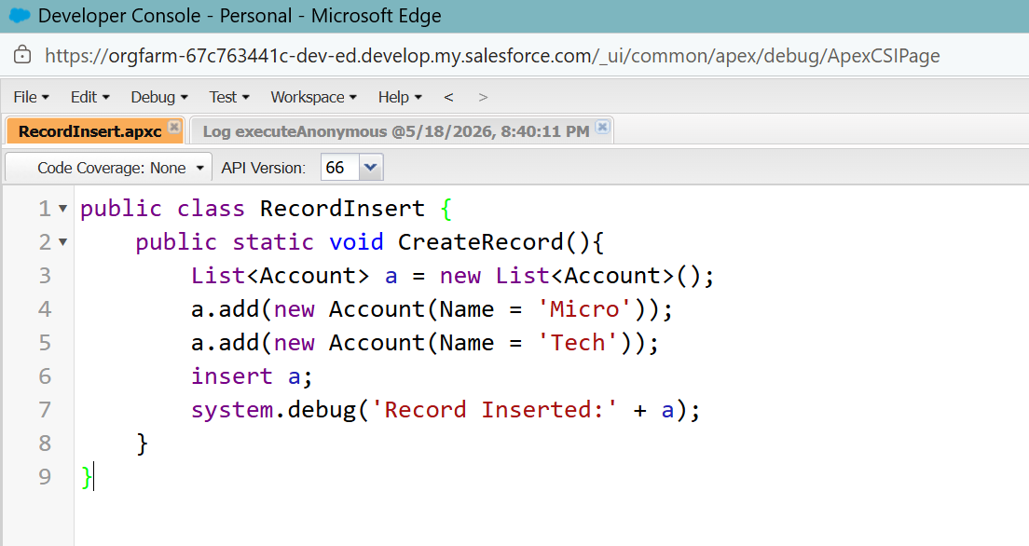

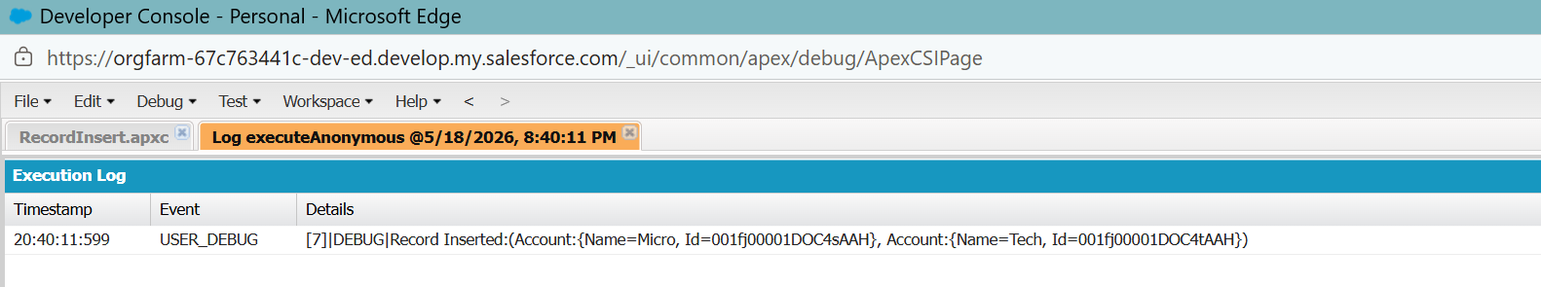

- Retrieve values from list using index.

public class AccountRetriever {
public static void ShowAccounts(){
List<Account> a = [Select Id, Name from Account LIMIT 3];
Account a_One = a[0];
Account a_Two = a.get(1);
system.debug('First Account:' + a_One.Id);
system.debug('Second Account:' + a_Two.Id);
}
}

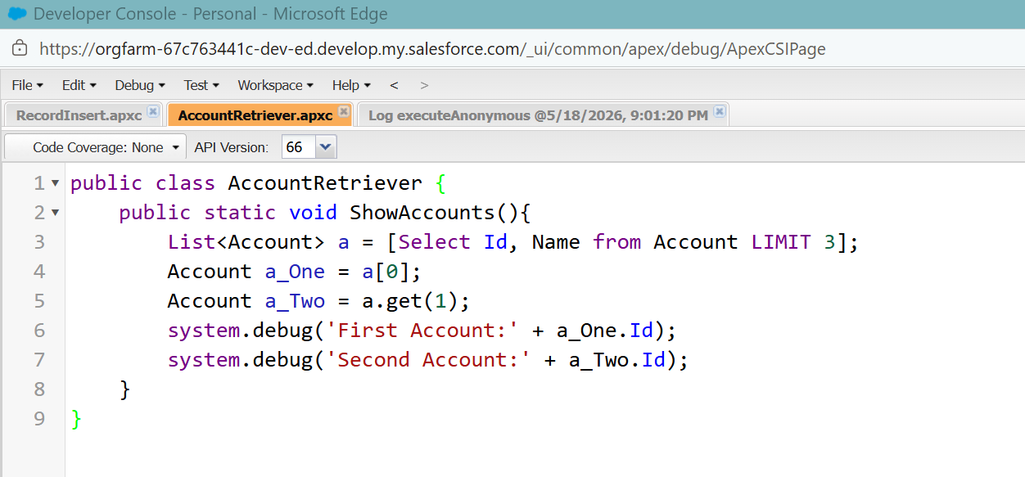

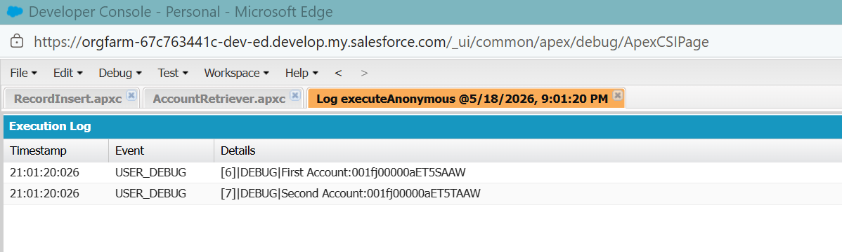

- Create a map of Account Ids and Account objects.

public class AccountMapper {
public static void showAccountMap(){
List<Account> a = [Select Id, Name from Account LIMIT 5];
Map<Id, Account> accMap = new Map<Id, Account>();
for (Account acc : a){
accMap.put(acc.Id, acc);
}
Account accObj = accMap.get(a[0].Id);
system.debug('Account Name:' + accObj.Name);
}
}

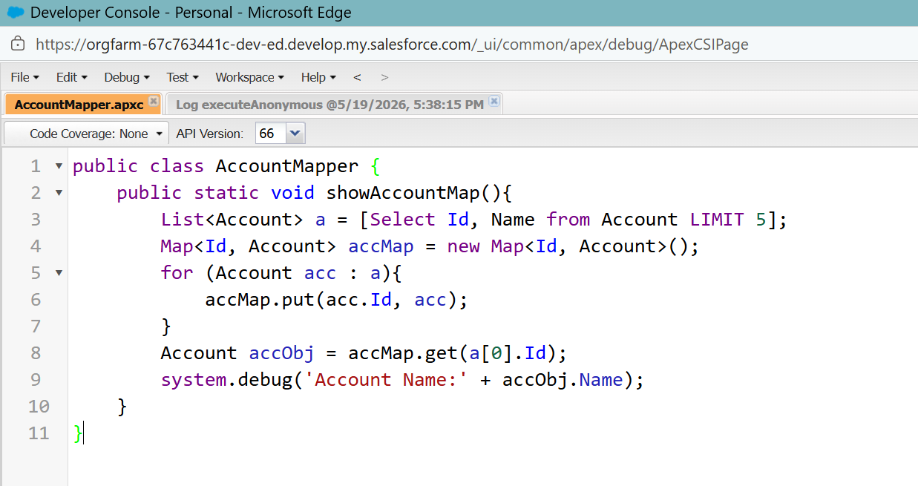

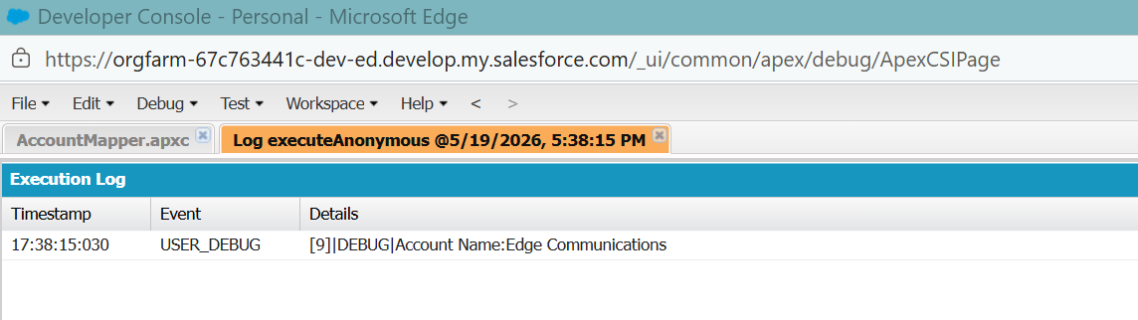

• Write an example of aggregate functions without using a GROUP BY clause.

public class AccountAggregrate {
public static void showAggregrateResults(){
AggregateResult r = [Select COUNT(Id) totalAccounts, Max(CreatedDate) latestAccount From Account];
system.debug('Total Account:' + r.get('totalAccounts'));
system.debug('Total Account:' + r.get('latestAccount'));
}
}

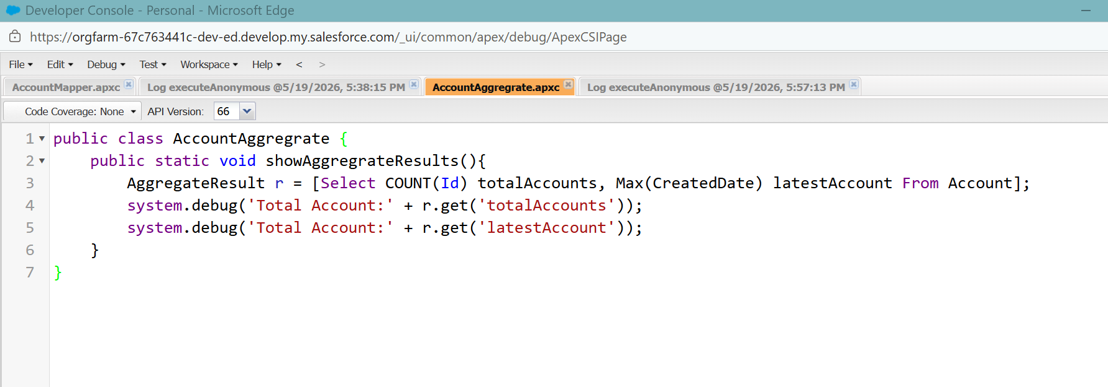

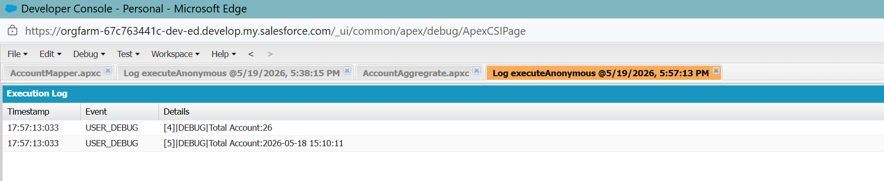

• Write an example Using SOQL Queries That Return One Record

public class oneRecord {
public static void showSingleRecord(){
List<Account> a = [Select Id, Name, Industry FROM Account LIMIT 1];
if(!a.isEmpty()){
system.debug('Account Id:' + a[0].Id);
system.debug('Account Name:' + a[0].Name);
system.debug('Account Industry:' + a[0].Industry);
}
}
}

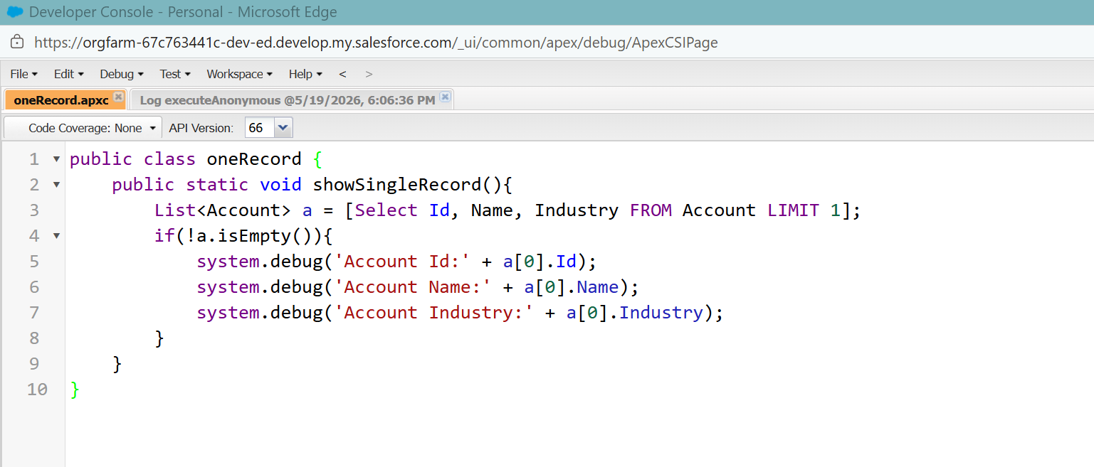

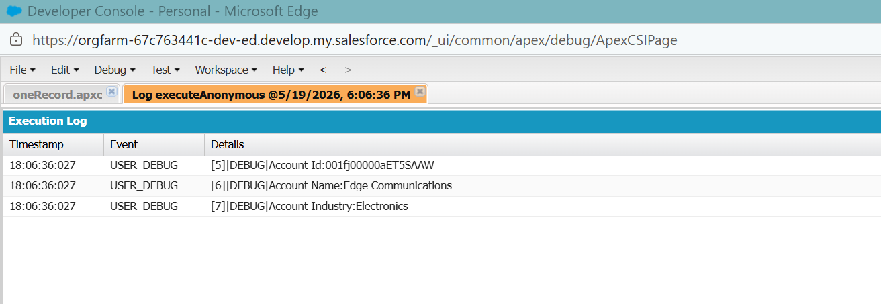

• Create new objects from SOQL queries on existing ones.
Example: Create New Contacts from Existing Accounts

public class CloneContact {
public static void ContactCopy(){
List<Contact> c = [Select FirstName, LastName, Email FROM Contact LIMIT 3];
List<Contact> nc = new List<Contact>();
for (Contact cnt : c){
Contact NewC = new Contact( FirstName = cnt.FirstName,
LastName = cnt.LastName + 'Copy',
Email = cnt.Email + 'copy');
nc.add(NewC);
}
insert nc;
system.debug('New Contacts Created are:' + nc);

}
}

